**Day 8 Lab Assignments**

**You can make the first bonus assignment (written in red) only instead all of the following assignments *or* if you need to start with simple tasks you can start with the following assignments, and work in the bonus after you finish them.**

1. In the login form assignment in Day.6 lab, use local storage to save user name and password in the prev. assignment, when user press login button, and retrieve them on page load and write them to the textboxes.
   1. Can you use session storage in the previous assignment? Why?
   2. What’s the difference between local storage and session storage?
   3. Can you access local storage and session storage in another page than the page that created it (on the same site)?
2. In the previous Assignment, add “remember me” check box, and save user name and password only if the user checked this checkbox, and if the user didn’t check it, remove the saved user name and password from local storage if they saved before.
3. Make JSON Object that holds Student data (ID, name, Age, Address, Skills (array), IsLeader (Boolean)). [Use JSON object and don’t use string in keys].
4. Make an array (of 3 students) of the previous student object, and print each student name along with his skills (make the address null for one of the students).
   1. Can JSON hold null and Boolean values?
   2. What are the differences between XML and JSON?
5. Use AJAX to retrieve user data, and display: First Name, Last name and user avatar image (show the user image in an <img> tag) from the following test web API: <https://reqres.in/api/users/1>
   1. Make a textbox where the user can enter user ID, and press display and then display the user with the given ID.
   2. Use this web API: <https://reqres.in/api/users> to return all users data, and make a dropdown list and fill it with students name returning form the API. (Loop on them and display all users).
   3. When user selects specific user (onchange event), display his data and image below the dropdown list.
6. In local storage Assignment (No.1) use **cookies** instead of local storage.

**Bonus:**

1. **[Big Bonus]** Create a simple E-commerce website from 2 pages:
   1. First page displaying products (use this API: <https://fakestoreapi.com/products>) in a list like the following image:

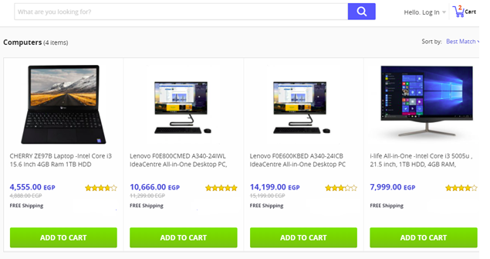

* 1. Use cookies or local storage to store the ID of the product, when user clicks (Add to Cart).
  2. In the first page add a link (like in the upper part of the previous image) to the second page (Shopping Cart), that lists the products added by the user (user can edit items count and can delete items), and calculate the total price and display it on the page (You’ll need to run your product from any local server so you can access cookies or local storage in all website page, for example you can use live server extension in Visual Studio code).

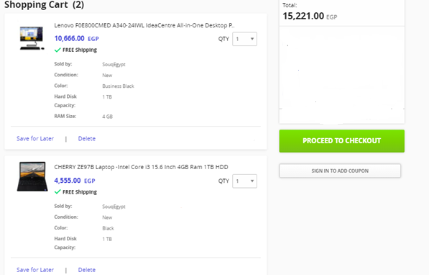

* 1. Make a details page for each product, when opened display all details of the selected product (Use this API: <https://fakestoreapi.com/products/id>).
  2. **Congratulations, you just finished your first pages in a simple E-commerce website☺.**

1. Use CSS to style the SD courses JSON data on the page.
2. Convert Given XML File, to JSON Object (in a variable inside HTML page), and Print its data in the page.
3. Read the SD courses JSON file using Ajax, and print its data on the page.
4. Read the given XML file using Ajax, and write its data to the page.
5. Do any missing assignments or bonus assignments in previous days.
6. Complete on your simple E-commerce website.

**<Script>document.write(“Thank YOU”) </Script>**